

Support Ticketing System

by

Ilkay Ates, Marcia Luna, Marcus Ritter, Shamil Fayzullin

SRH University Heidelberg
Faculty of Information, Media and Design
Applied Computer Science
Software Architecture and Development

Submission Date: 00.00.0000

Reviewer: Christoph Hahn M.Sc.
Document History

Table 1 Document history
Version | Date | Change
1.0 | 16.04.2017 | Draft version prepared

Table of Content

1 About this Document 7
1.1 Authors 7
1.2 Project Scope 7
1.3 Document Structure 7
1.4 Glossary 7
2 Design Thinking 9
2.1 Students 9
2.1.1 Persona 9
2.1.2 Experience journey 9
2.2 Support Team Member 9
2.2.1 Persona 9
2.2.2 Experience journey 9
2.3 Support Team Manager 9
2.3.1 Persona 9
2.3.2 Experience journey 9
3 Software Requirements 10
3.1 Business Requirements 10
3.2 User Interfaces 10
3.3 Roles and Authorizations 11
4 Solution 12
4.1 Solution Overview 12
4.2 User Interfaces 13
4.2.1 Student 13
4.2.2 Support Team Member 23
4.2.3 Support Team Manager 34
4.3 Roles and Authorizations 42
5 References 43

List of Figures

Figure 1 Solution architecture 13
Figure 2 Fiori Launchpad 15
Figure 3 text 16
Figure 4 text 17
Figure 5 text 18
Figure 6 text 19
Figure 7 text 20
Figure 8 text 21
Figure 9 text 22
Figure 10 text 23
Figure 11 text 24
Figure 12 text 25
Figure 13 text 26
Figure 14 text 27
Figure 15 text 28
Figure 16 text 29
Figure 17 text 30
Figure 18 text 31
Figure 19 text 32
Figure 20 text 33
Figure 21 text 34
Figure 22 text 35
Figure 23 text 36
Figure 24 text 37
Figure 25 text 38
Figure 26 text 39
Figure 27 text 40
Figure 28 text 41
Figure 29 text 42
Figure 30 Roles and Authorizations 43
List of Tables

Table 1 Document history 2
Table 2 Authors 7
Table 3 Glossary 7
Table 4 Business requirements 10
Table 5 Work tasks according to their business roles 11

About this Document

Authors
Table 2: Authors
Name | Project Role
Ates, Ilkay | Business Analysis, Frontend Development
Luna, Marcia | Mock-Up Design, Frontend Development
Ritter, Marcus | Software Architecture, Frontend Development
Fayzullin, Shamil | Project Management, Backend Development

Project Scope
Regarding the support requests of students in the previous years, necessity of a support ticketing system application has been established. This application is designed as a platform where students will find a variety of predefined solutions and additionally, they will have the possibility to create new tickets regarding their needs. There are three user types in this application: student, support team member and support team manager.
Students can search and view predefined solutions which will be organized by categories. In case they cannot find solutions regarding their requests or questions, they can create new tickets. After a ticket has been resolved, the student will be asked to fill a satisfaction questionnaire. This will provide the rating of the support and will be used for analytics to improve the system.
Support team members can create and edit solution categories which are necessary to facilitate solution search for students. They can create and edit predefined solutions and resolve tickets which are created by students. Number of open tickets with a link to the list will be displayed on the initial screen of support team member, this will provide an easy insight to reach the waiting requests.
Support team manager will be able to view all tickets. On the initial screen, a link to overdue tickets which are not responded within 48 hours will be displayed. Support team manager can assign these tickets to support team members. Additionally, analytics will be provided for support team manager which can be filtered for a specific period and/or responsible support team member. Different analytics will be displayed based on the ticket status or ratings of the provided solution.

Document Structure
This document is structured as follows:
Chapter 1 of this document includes project scope and formal aspects about the project and team members.
Chapter 2 describes the design thinking with methods of personas and user experience journeys.
Chapter 3 includes software requirements.
Chapter 4 describes the solution in relation to requirements described in chapter 3.
Chapter 5 provides a list of references.

Glossary
Table 2 Glossary
Term | Abbreviation | Definition
HANA Cloud Platform | HCP | SAP HANA Cloud Platform is an in-memory cloud platform based on open standards. It provides access to a feature-rich, easy-to-use development environment in the cloud. The platform includes a comprehensive set of services for integration, enterprise mobility, collaboration, and analytics. (SAP, 2016b)
SAPUI5 |  | JavaScript UI library, maintained by SAP SE company
Fiori |  | Fiori applications are built with SAPUI5. SAP Fiori apps follow the SAP Fiori Design Guidelines to ensure consistent design and a high level of design quality. For more information, please see https://experience.sap.com/fiori-design/. (SAP, 2016c)
OData protocol | OData | OData (Open Data Protocol) is an OASIS standard that defines a set of best practices for building and consuming RESTful APIs. (OData, 2015)

Design Thinking

Students

Persona
Jane is a master student with a Bachelor degree in business administration. She has average computer skills, so she needs some technical support when she has to deliver assignments for her lectures for which she needs to use some applications. She also needs help to get an access for student portal where all her lecture’s content are published.
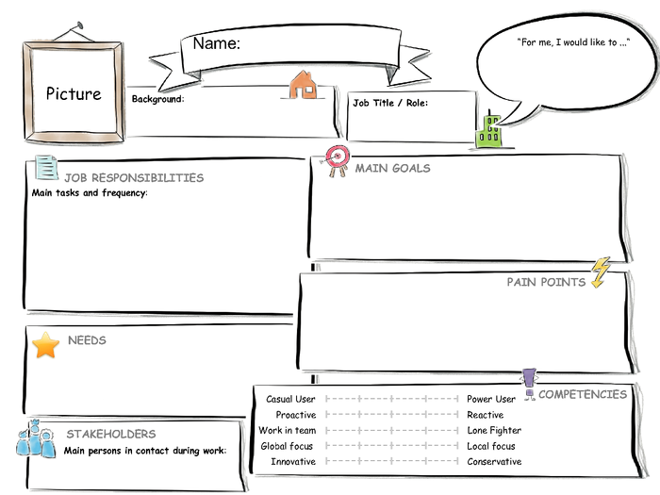
Get lecture content,
deliver assignments/lecture projects on time,
pass exams
Support team member
I would like to get technical support during my master program
Master Student
Jane
Bachelor degree in business administration, first semester in master program, average computer skills
I need support to prepare projects with software tools, to access online student portal
Attend lectures on time,
prepare and deliver assignments/projects,
sign in for exams, c
heck exam results
Lack of technical skills to deliver assignments/projects

Experience journey
A student needs the content of his lecture. To reach the content he needs access to student portal. He thinks of getting the content from a classmate but decides to ask for access to support team, because he will need it for the rest of his studies. He is concerned of being already late and considers talking to the teacher. After sending an email to support team he waits for a response. Next day he receives a response which describes how to get access to the portal.
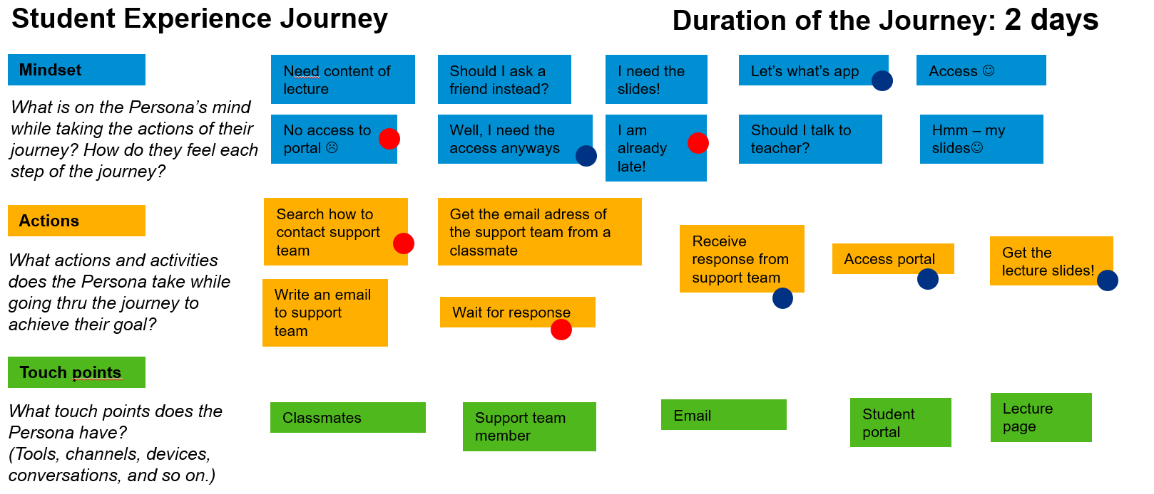

Support Team Member

Persona
Marc is a member of support team. He studied information systems and has 3 years of work experience in IT departments of several companies. He would like to achieve high performance on delivering support on time. To reduce his response time to the requests, a dashboard with a list of open tickets would be very helpful for him. The strongest pain point for him is the communication with the requester. He needs a platform where he can see all communication history to follow up the case easier.
Resolve issues of students within 24 hours
Students,
Support team manager
I would like to achieve high performance on delivering support on time to students
Support Team Member
Marc
Studied information systems, worked 3 years in it department, very good computer skills
I need a dashboard to see new and open tickets, a platform that I can contact the requester.
Provide support/information to students

Lack of sufficient information about the support needed, lack of notification on time.

Experience journey
Support team member opens his mailbox to read the support mails. He has to read them to find out which one is more urgent. In some cases he needs extra information from the requester and waits for his response to solve the issue. When he has all necessary information, he sends the solution to the requester and waits for his confirmation.
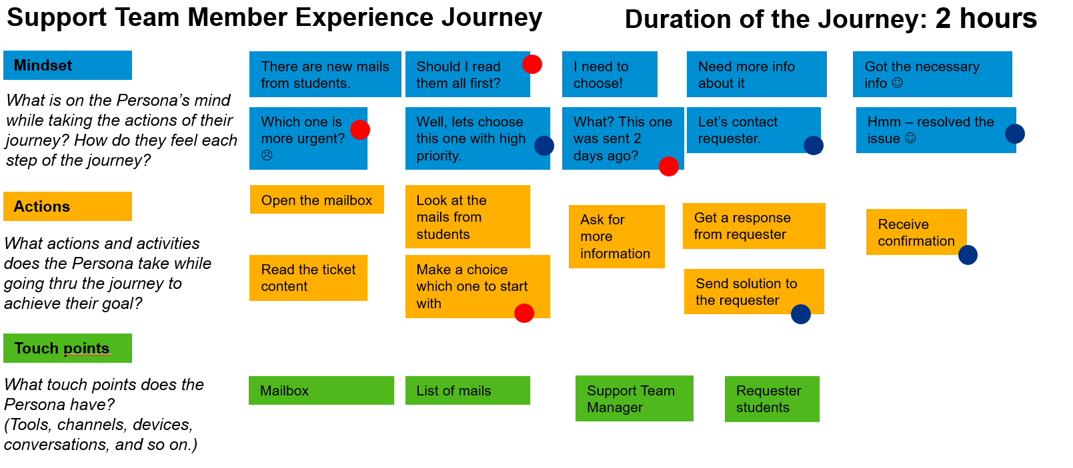

Support Team Manager

Persona
Albert is the support team manager. He studied information systems and worked for 8 years in IT and support departments of several companies. His goal is to improve efficiency and effectiveness of support team. He needs a real time insight for overdue requests so that he can assign them manually to avoid late support. He spends much time to create performance reports so analytics will facilitate his job to review performance of his team.
Reduce response time for support requests,
Reduce overdue support requests,
Improve support for students
Support team members,
Students
I would like to improve efficiency and effectiveness of support team
Support Team Manager
Albert
Studied information systems, worked 8 years in it and support departments, very good computer and management skills
I need to reduce response time for support requests, I need realtime insight of support team activities
Oversee daily support activities, handle overdue support requests,
supervise support team members,
manage support team performance
Excessive time spent to create reports of support team activities,
Late insight into overdue support requests

Experience journey
Support team manager opens his mailbox to follow up on overdue tickets. He needs to check every mail to find out if it is in process or still waiting. For the requests which are overdue, he assigns them to the available support team member. To view performance results of the team he needs to create reports manually and read feedback mails from students.
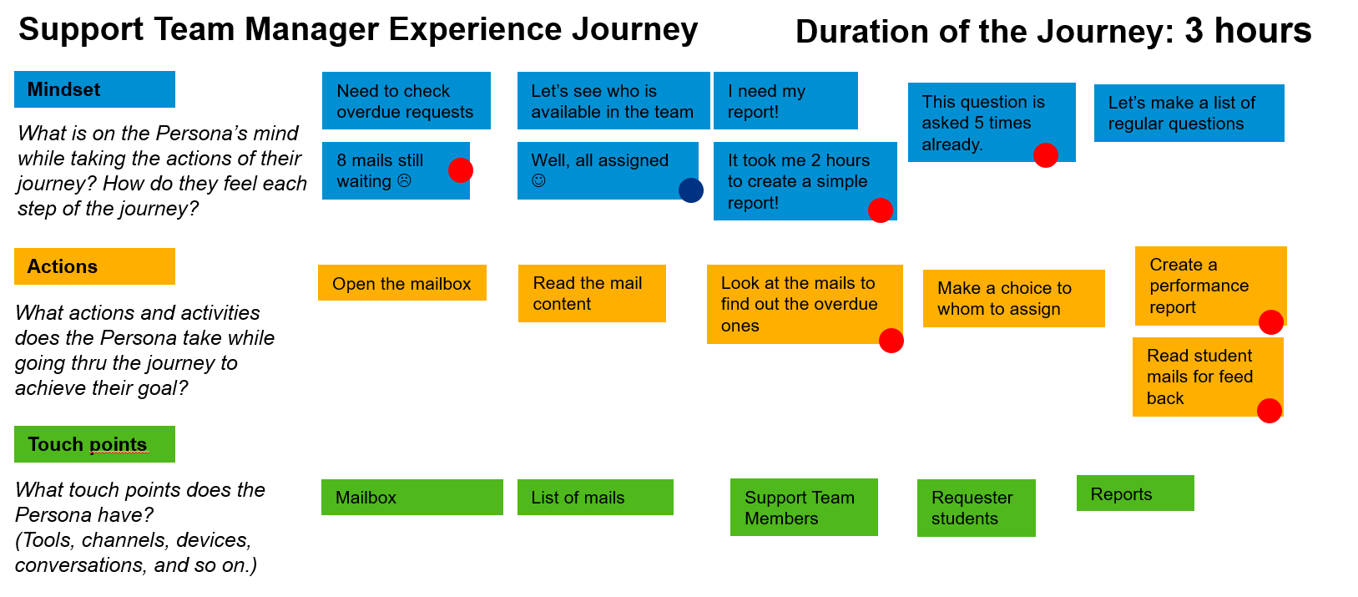

Software Requirements

Business Requirements

Table 3 Business requirements
№ | Requirement | Necessity
1 | The Support Ticketing System should support the creation and maintenance of predefined solution categories. | Must have
2 | The Support Ticketing System should provide functionality to create predefined support solutions and to categorize them. | Must have
3 | The Support Ticketing System should support the creation of new support tickets. | Must have
4 | For the process flow of a support ticket, the Support Ticketing System should support status changes of the ticket. | Must have
5 | The support Ticketing System should provide notifications for the students, which will be displayed on initial screen and provide the number of tickets to be confirmed. | Nice to have
6 | The support Ticketing System should provide notifications for the support team members, which will be displayed on initial screen and provide the number of open tickets. | Nice to have
7 | The support Ticketing System should support support manager to assign tickets to support team members. | Must have
8 | The support Ticketing System should provide notifications for the support manager, which will be displayed on initial screen and provide the number of overdue tickets that are not being process within 48 hours. | Nice to have
9 | After a ticket is been resolved, the Support Ticketing System should provide a questionnaire to gather the rating of the provided support. | Nice to have
10 | The Support Ticketing System should provide analytics for support manager which will be filtered based on ticket status or raiting of support team members. | Nice to have

User Interfaces
Support Ticketing System should comply with the following requirements:
- Support Ticketing System should support use of the following web browsers (IE, Chrome, Edge).
- Support Ticketing System should be used on PC, tablets and smartphones.
- Support Ticketing System should be based on HTML5.
- Support Ticketing System should follow user-friendly interface design principals.

Roles and Authorizations
Support Ticketing System should support a role-based authorizations and access control. This system will be used by different users that can have the following roles based on associated scenarios and authorizations:
- Student
- Support Team Member
- Support Manager

The following table describes typical work tasks for each business role in more detail:

Table 4 Work tasks according to their business roles
Student | Support Team Member | Support Team Manager
- Create new ticket  - Response ticket  - Confirm ticket  - Give feed-back for provided support  - Search predefined solutions | - Create predefined solution categories  - Create predefined solutions  - Resolve Tickets | - Assign Tickets  - Display Analytics

Solution

Solution Overview
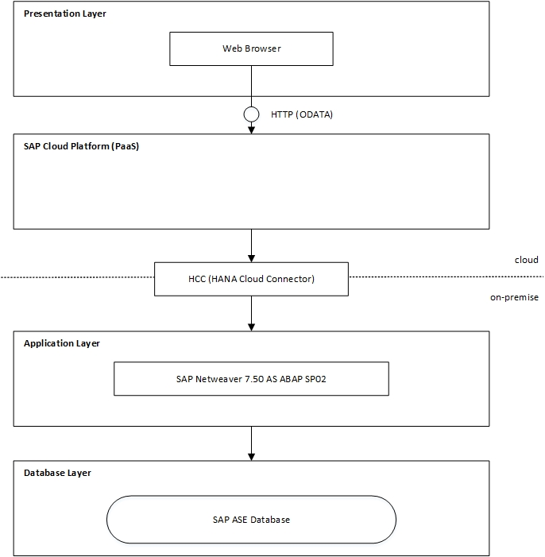
Figure 1 Solution architecture
The Support Ticketing System uses three tier architecture and therefore consists of three layers: presentation tier, application tier and data tier. Information and idea are according to SAP courses design and SAPUI5. SAP Cloud Platform is which layer???

Presentation tier:
text

Application tier:
text

Data tier:
text

User Interfaces
In order to meet the customer’s user interface requirements, the SAP Fiori design guidelines were applied (SAP, 2017b). Additionally, SAP Design Stencils for Microsoft PowerPoint were used to create low-fidelity Wireframes and in a second step enhanced to Visual Designs (SAP, 2016a). Furthermore a high-fidelity prototype was created with build.me (SAP, 2017a). According to this high-fidelity prototype the Support Ticketing System will be developed using the SAP Fiori framework. This framework is based on SAPUI5 libraries (HTML5) which allow the creation of responsive interfaces for different types of devices like laptops, mobiles, PCs and browsers e.g. IE, Chrome or Edge. The pursued approach and used methodology is based on the SAP Course “Build your own SAP Fiori App in the Cloud – 2016 Edition” (Raz Korn, 2016).
The high-fidelity prototype does not cover any possible use case scenario (changes during implementation phase are likely to happen). Nevertheless, it shows the key functionality of the Support Ticketing System and provides an example for the look and feel of the finalized user interface. The following subsections present three basic usage scenarios in respect of the different user groups: Students, Support Team Members, Support Team Managers.

Student

Login
Following figure displays the login screen of the Support Ticketing System. Based on the entered user credentials, role of the user will be identified and next screen will be displayed based on the role of the user.
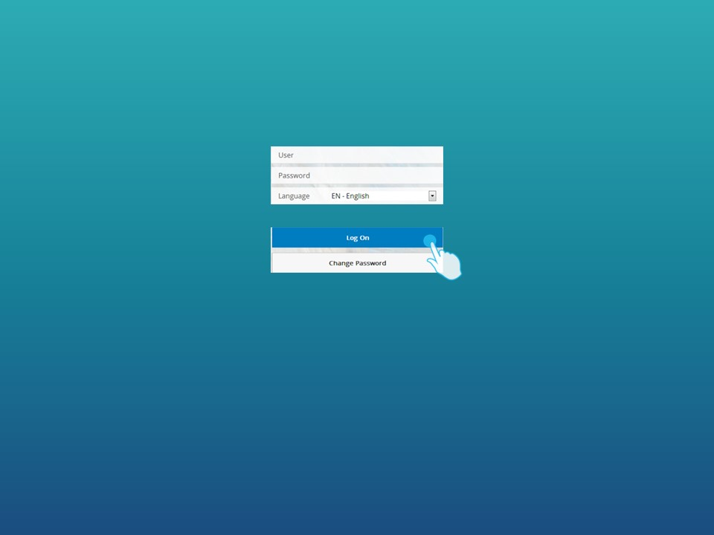
Figure 2 Fiori Launchpad

My Home
On the initial screen of student, three links will be displayed; predefined solutions, tickets created by the student and new ticket.
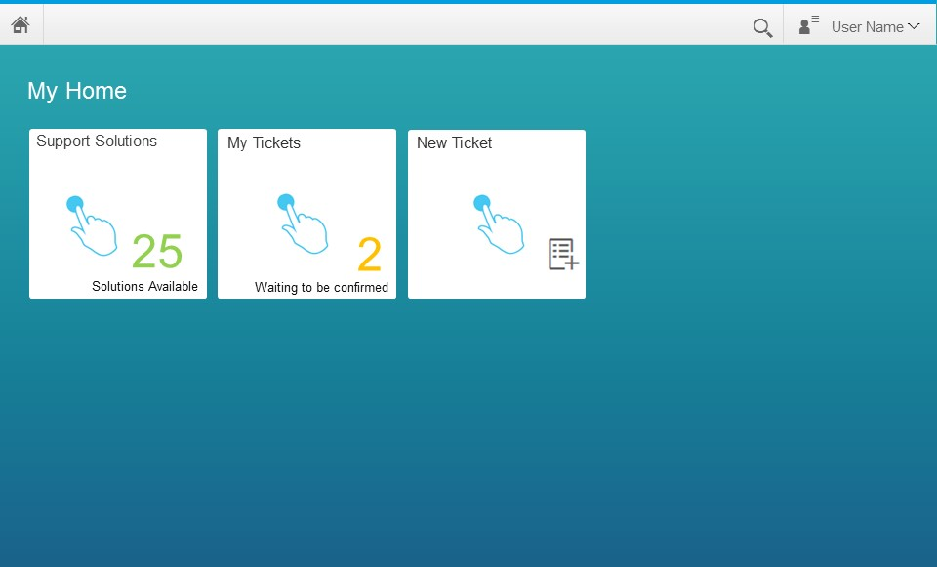
Figure 3 Home Screen for Student

Support Solutions
This screen consists of two panes. On the left pane, categories which include predefined support solutions will be displayed. Based on the choice of student, a list of predefined support solutions which belong to the related category will be displayed on the right pane.
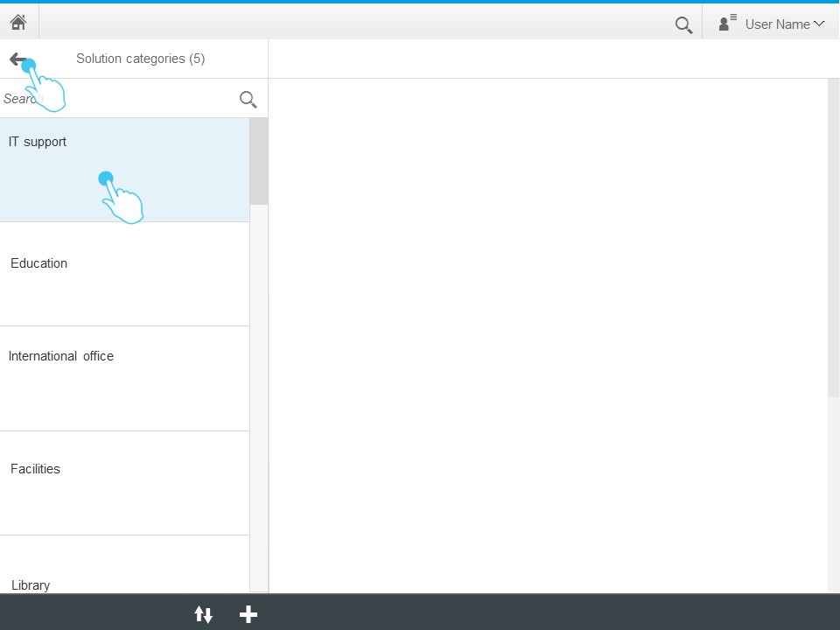
Figure 4 Predefined Support Solution Categories
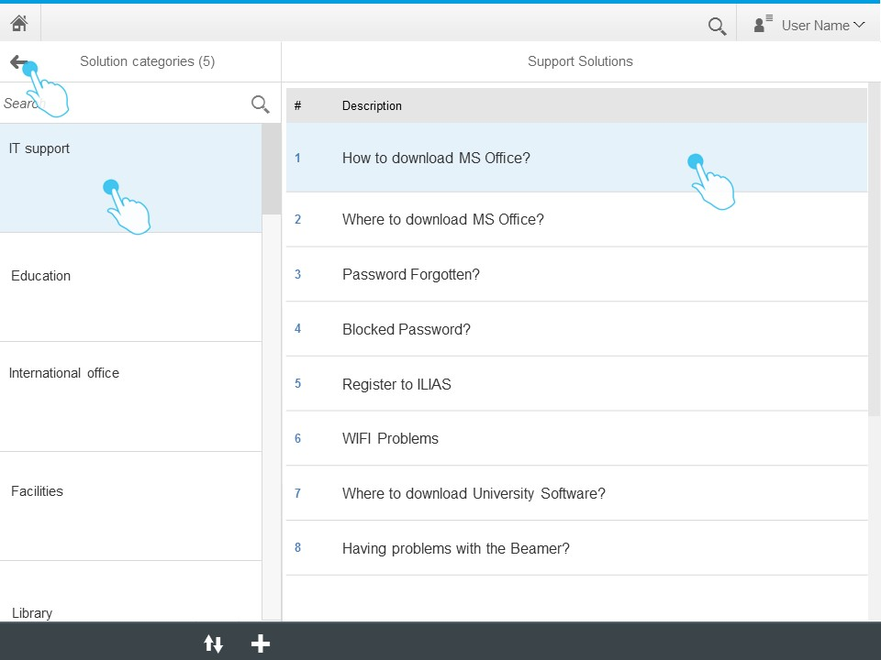
Figure 5 List of Predefined Support Solutions

Based on the choice of student, the content of selected predefined support solution will be displayed on the right pane.
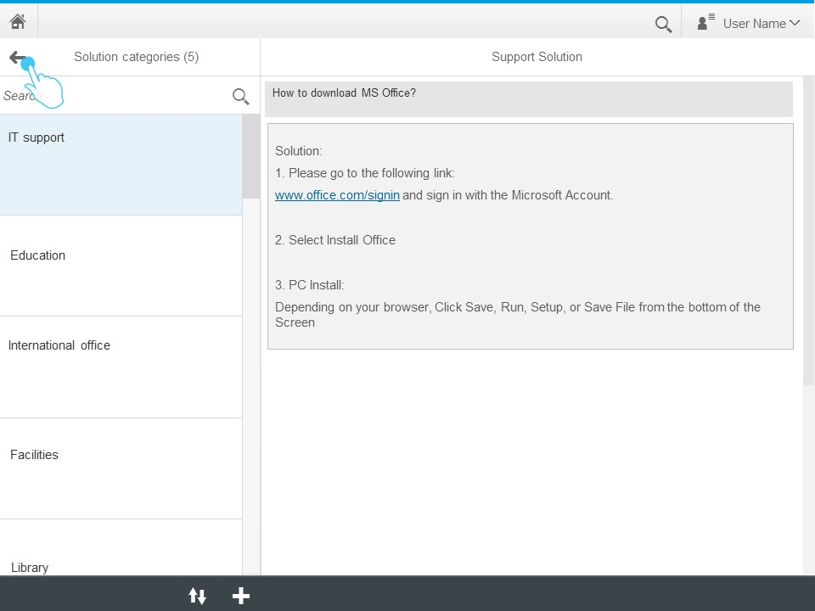
Figure 6 Predefined Support Solution

My Tickets
My Tickets screen consist of two panes; on the left pane, the list of tickets which are created by the student will be displayed. On the header, the number of tickets will be provided. Each ticket number will be listed with the current status of the ticket.
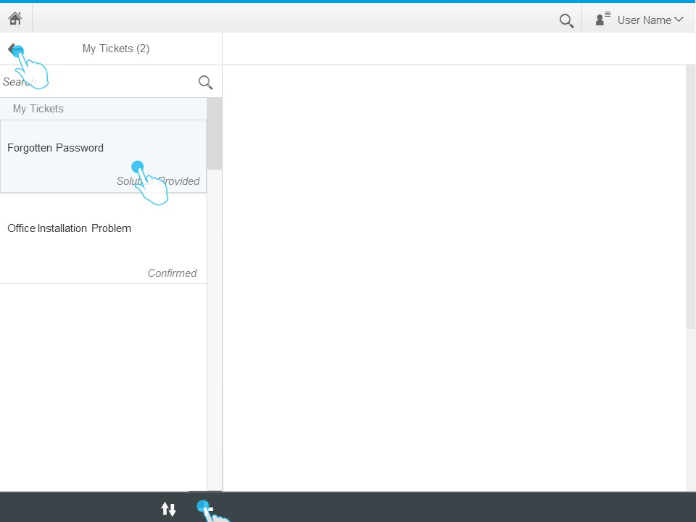
Figure 7 List of My Tickets

When the student clicks on of the tickets on the list, the details of this ticket will be displayed on the right pane. Based on the status of the ticket, student will be able to send a response or confirm the ticket.
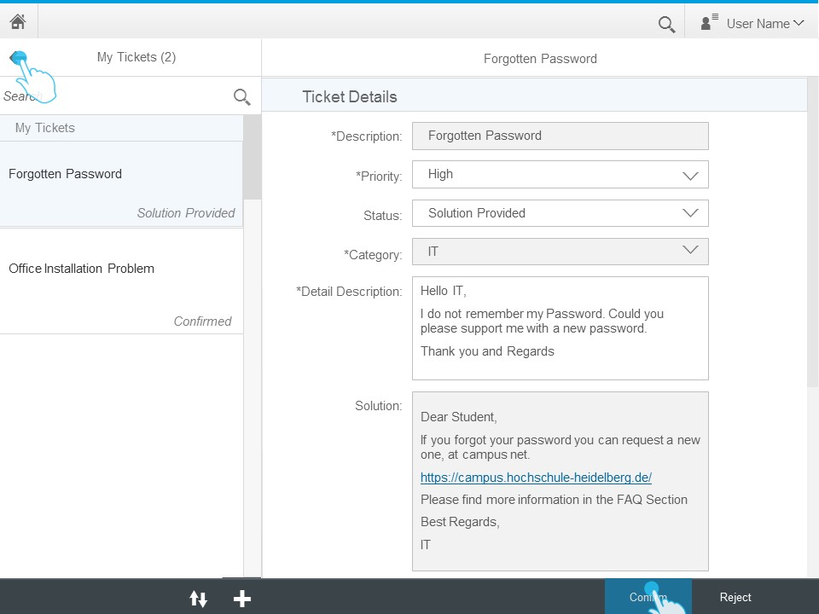
Figure 8 Ticket Details

Feedback
After a ticket is confirmed by the student, a feed back questionnaire will be displayed on the right pane. The rating given by the student for the provided support will be saved for analytics which will be provided to support team manager.

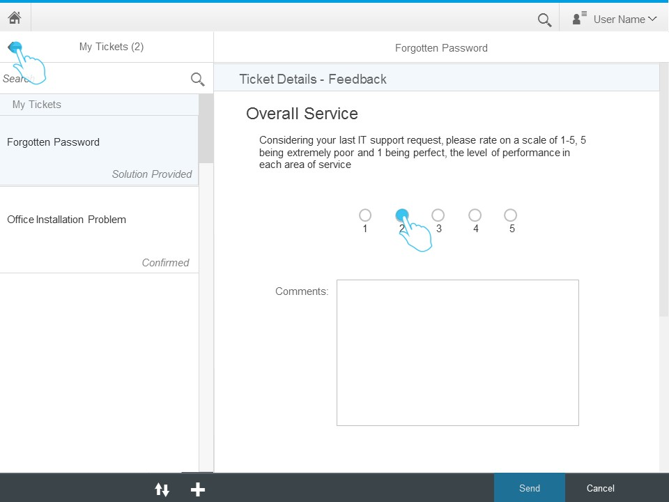
Figure 9 Feedback

New Ticket
On the New Ticket screen, following fields will be displayed:
Description: Short title, which will describe the content of the ticket.
Priority: A list with three options: low, medium, high.
Status: Disabled field to display the status of the ticket.
Category: Category of the ticket, which can be edited also by the support team members.
Issue Detail Description: Detailed description of the issue which needs support.

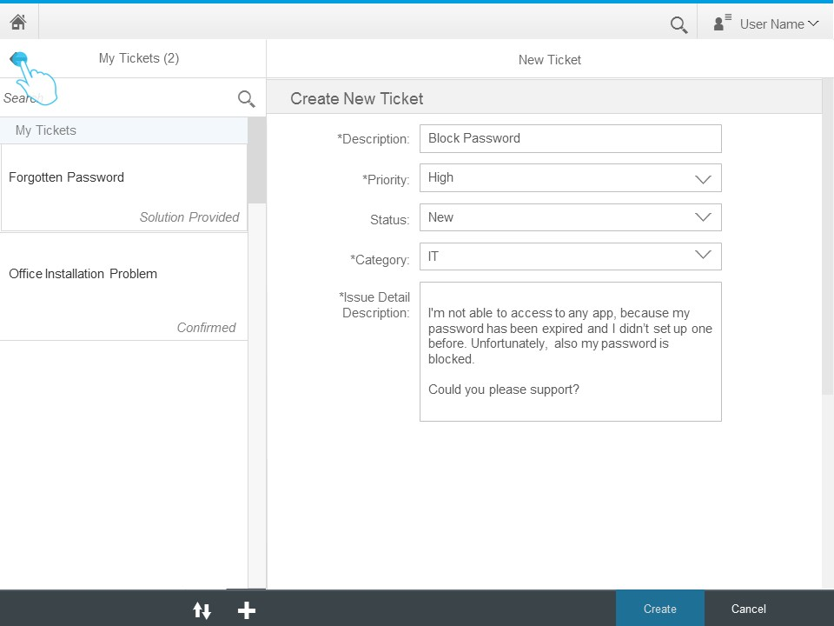
Figure 10 Create New Ticket

Support Team Member
text
Figure 10 text

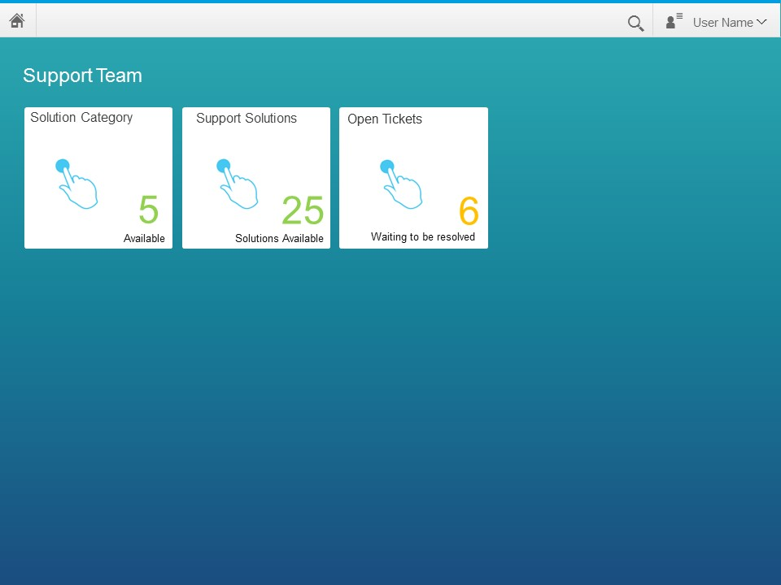
Figure 11 text

Solution Category
text
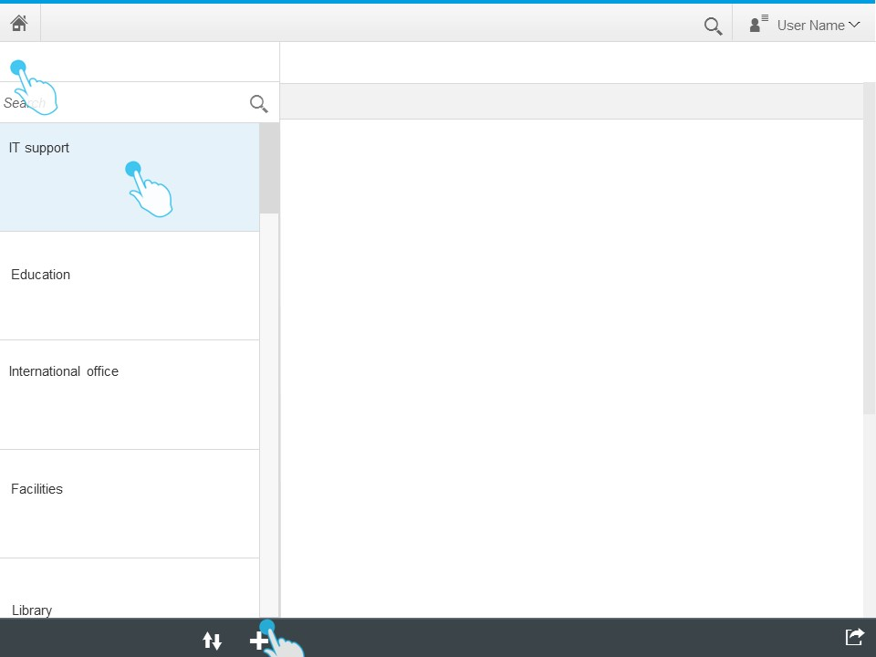
Figure 12 text

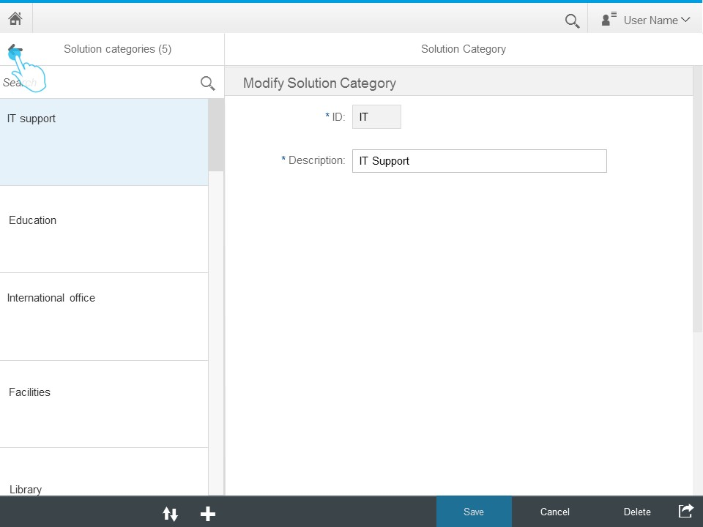
Figure 13 text

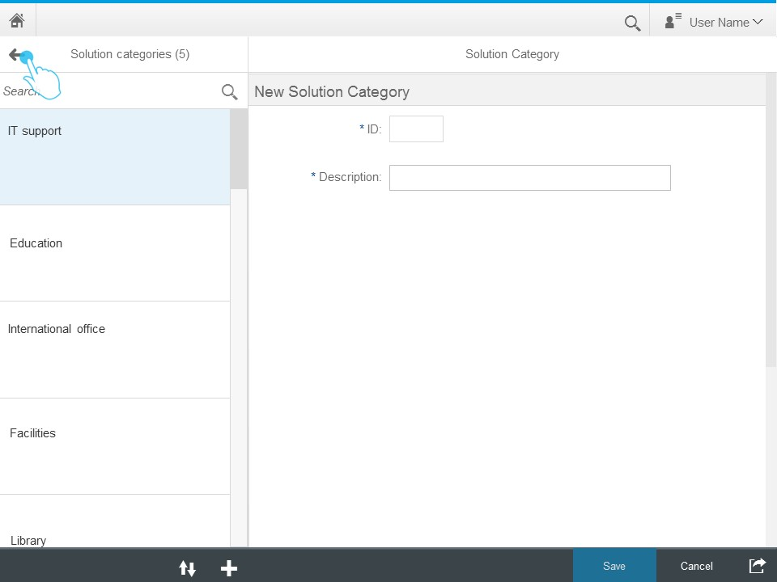
Figure 14 text

Support Solutions
text

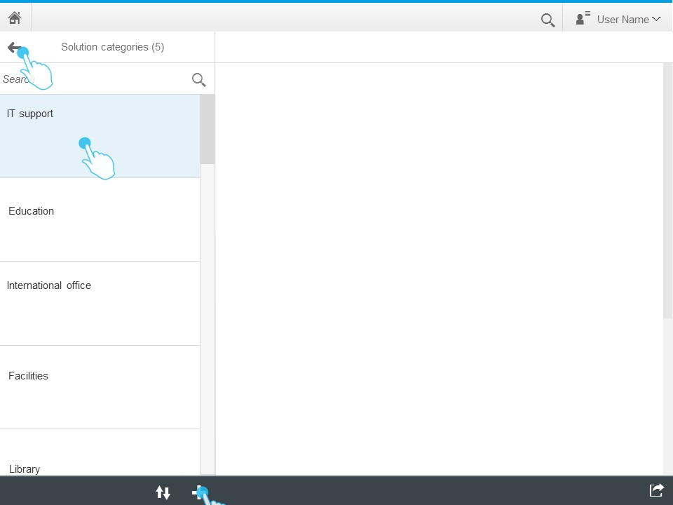
Figure 15 text

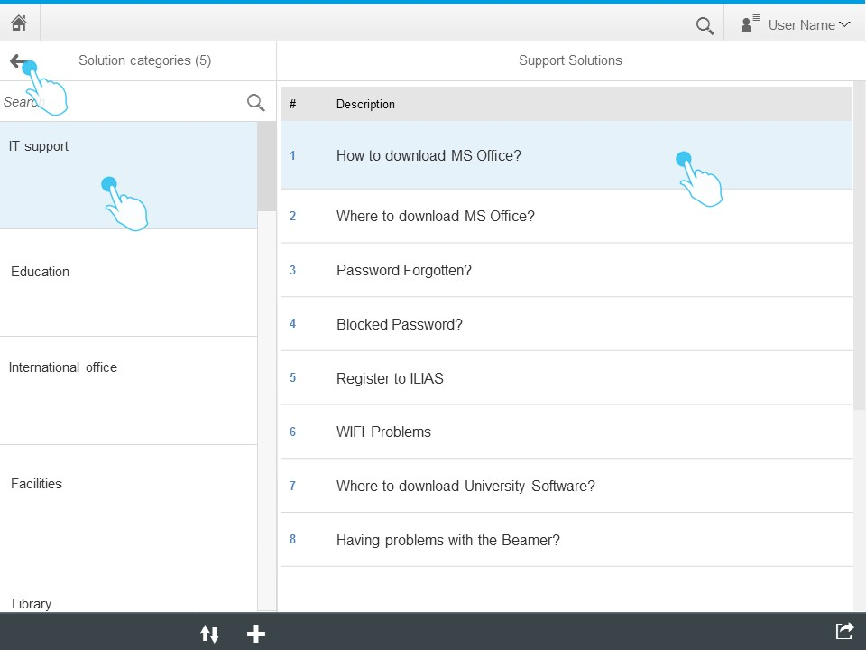
Figure 16 text

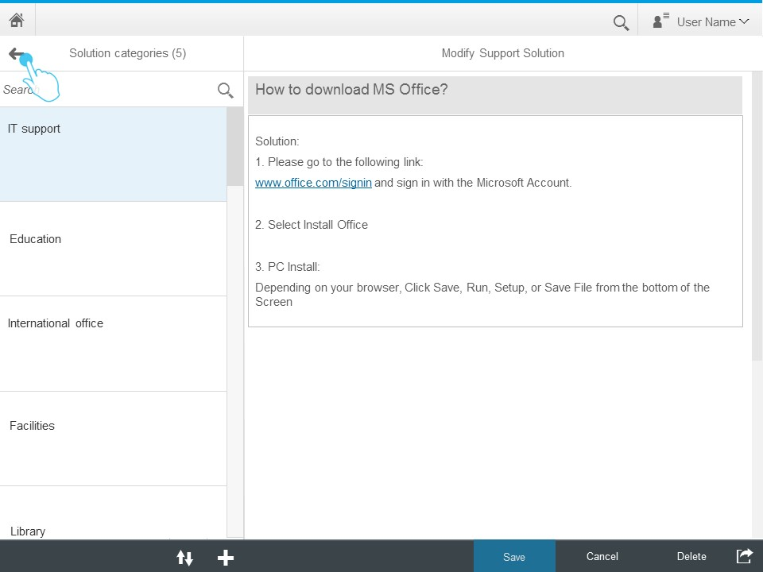
Figure 17 text

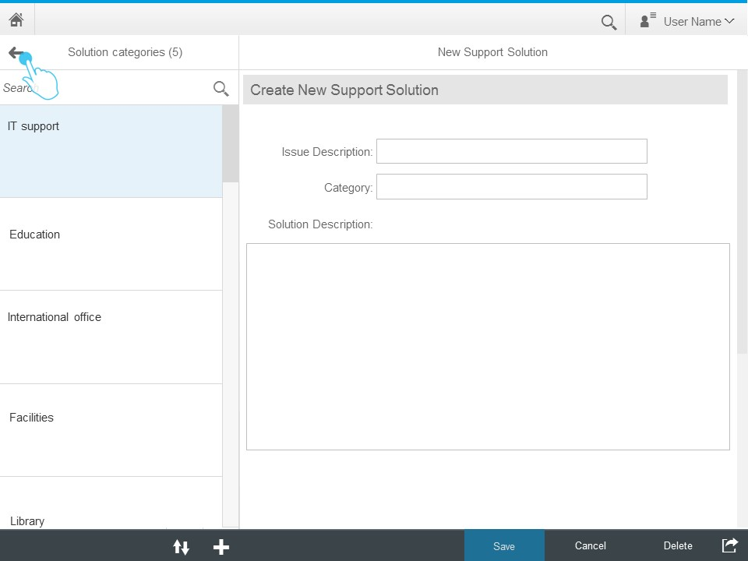
Figure 18 text

Open Tickets
Text

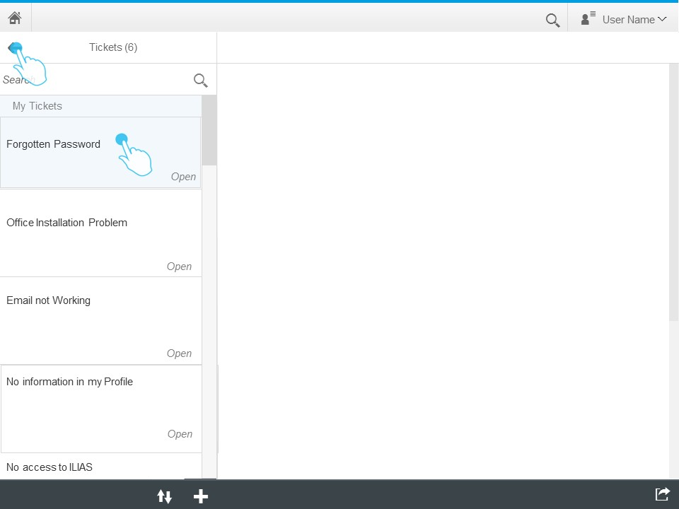
Figure 19 text

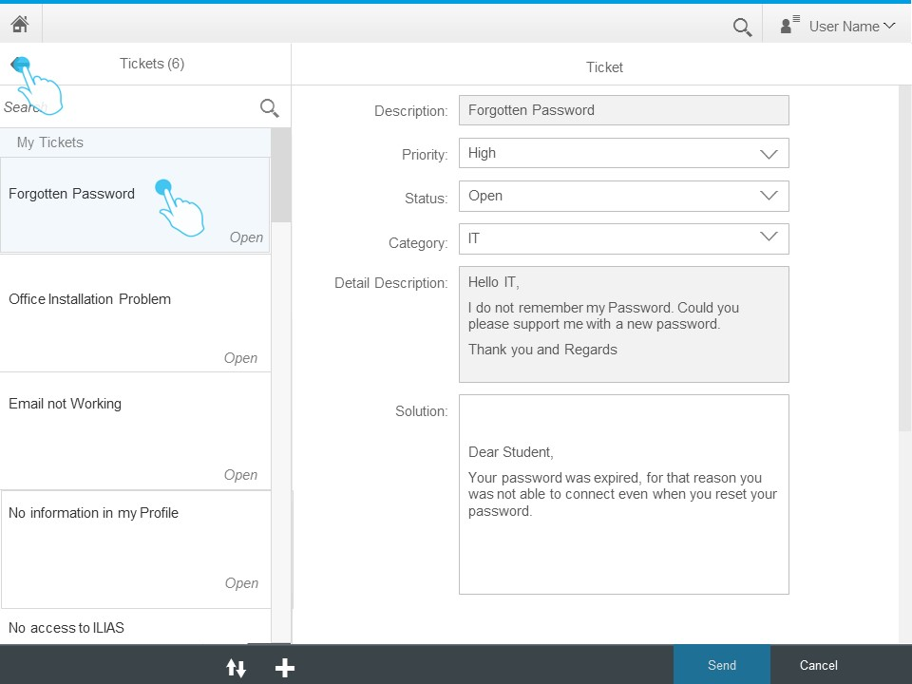
Figure 20 text

Support Team Manager
text
Figure 21 text

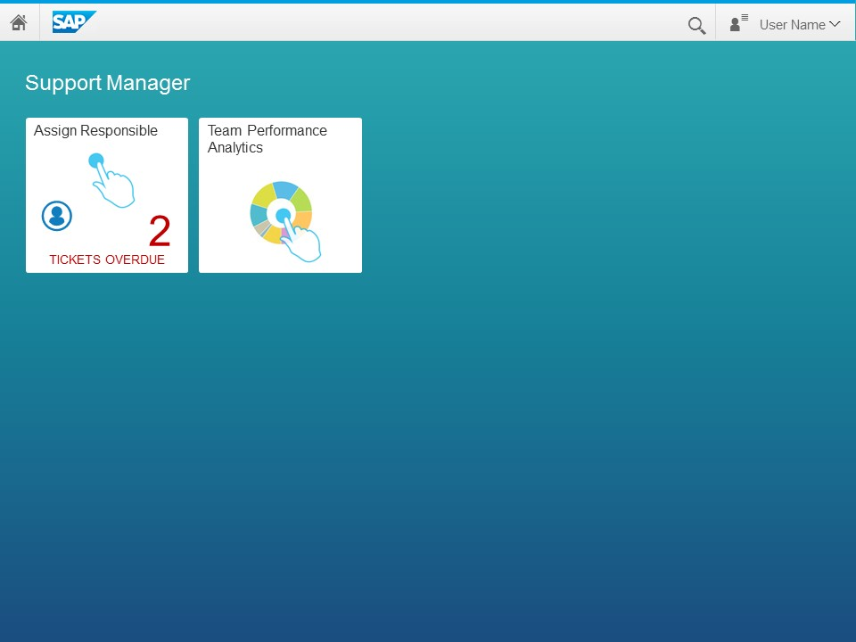
Figure 22 text

Assign Responsible
text
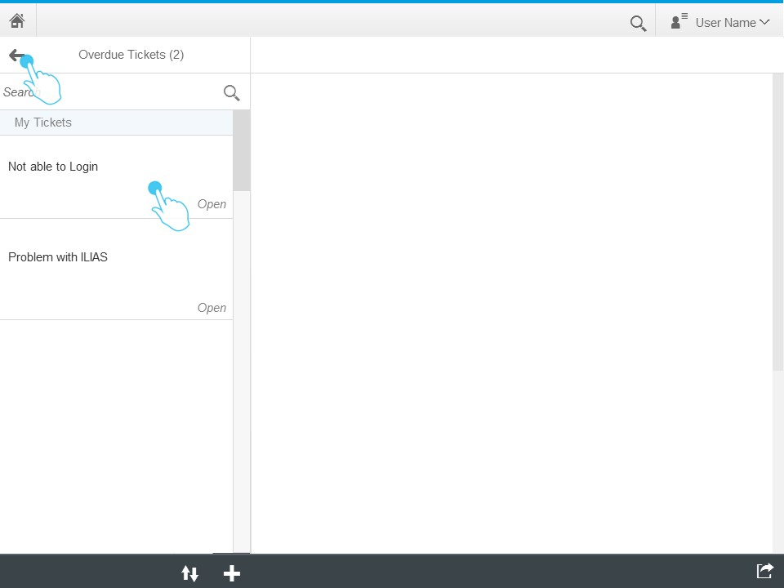
Figure 23 text
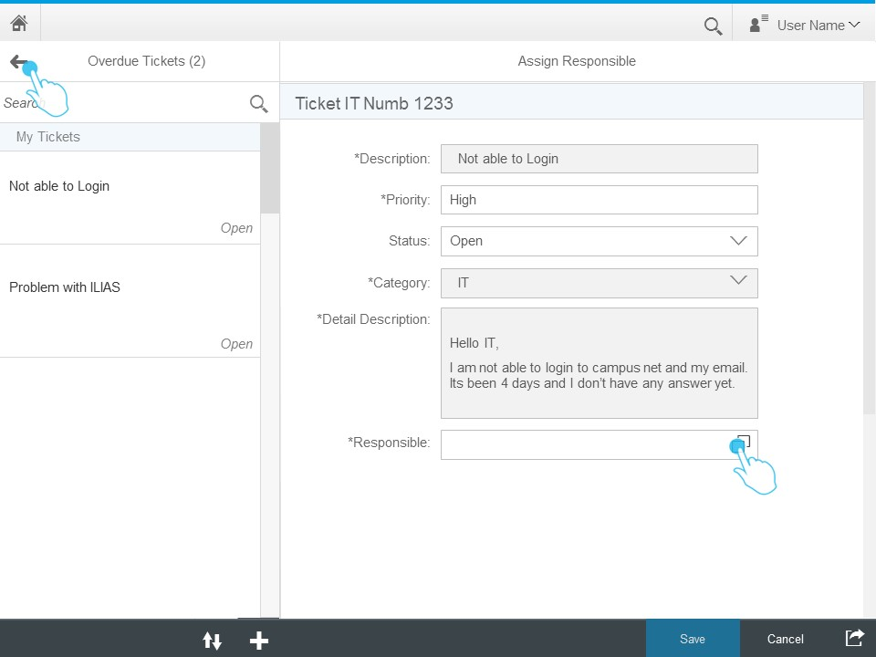
Figure 24 text
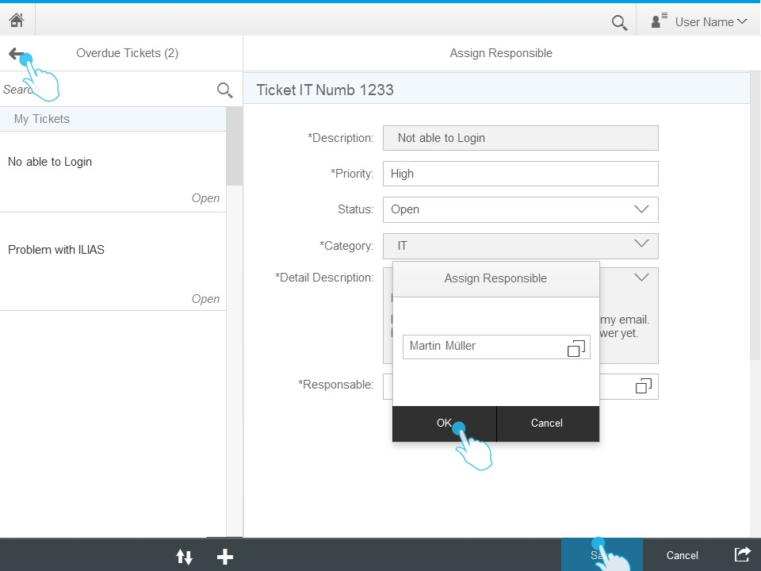
Figure 25 text
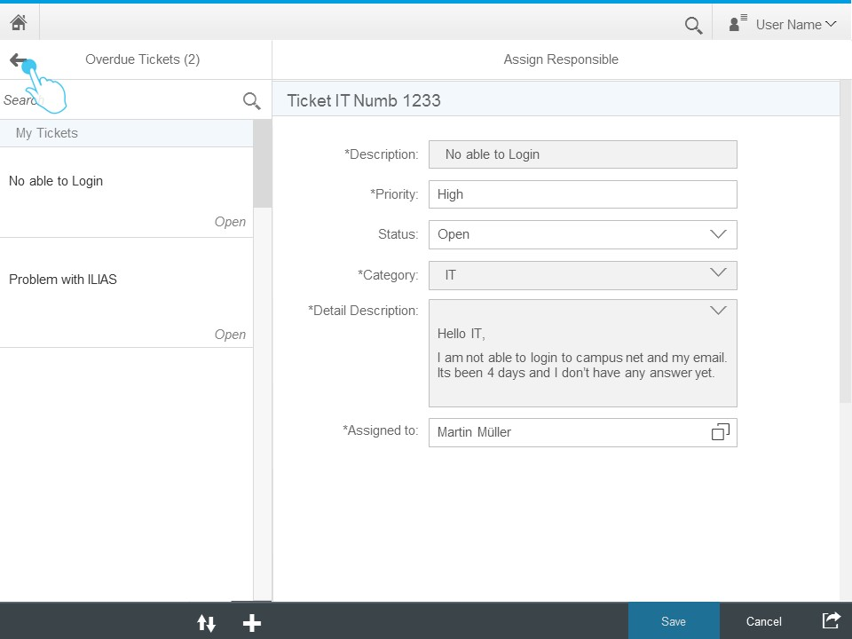
Figure 26 text

Team Performance Analytics
text
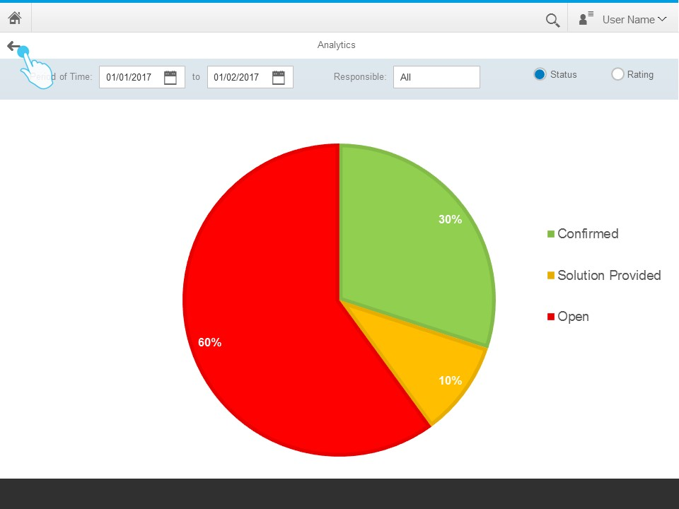
Figure 27 text

Roles and Authorizations
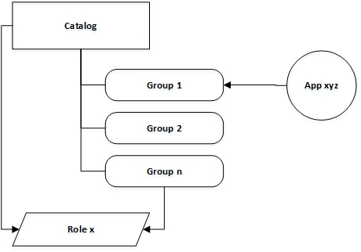
Figure 28 Roles and Authorizations
Put roles and authorizations text here.

References
Raz Korn, 2016. Build Your Own SAP Fiori App in the Cloud [online]. 5 May 2016, 12:00 [viewed 12 April 2017]. Available from: https://open.sap.com/courses/fiux2
SAP, 2016a. Design Stencils [online]. SAP Fiori Design Guidelines. 11 November 2016, 12:00 [viewed 12 April 2017]. Available from: https://experience.sap.com/fiori-design-web/downloads/
SAP, 2016b. SAP HANA Cloud Documentation [online]. SAP HANA Cloud Platform - Product Overview. 20 October 2016, 12:00 [viewed 1 November 2016]. Available from: https://help.hana.ondemand.com/help/frameset.htm?e7c9982cbb571014a97a8a675cf28c15.html
SAP, 2016c. SAPUI5: UI Development Toolkit for HTML5 [online]. 28 September 2016, 12:00 [viewed 1 November 2016]. Available from: https://sapui5.hana.ondemand.com/#docs/guide/95d113be50ae40d5b0b562b84d715227.html
SAP, 2017a. BUILD [online] [viewed 12 April 2017]. Available from: https://www.build.me/splashapp/
SAP, 2017b. SAP Fiori Design Guidelines [online]. SAP Fiori and Design Principles. 11 November 2016, 12:00 [viewed 12 April 2017]. Available from: https://experience.sap.com/fiori-design-web/design-principles/

